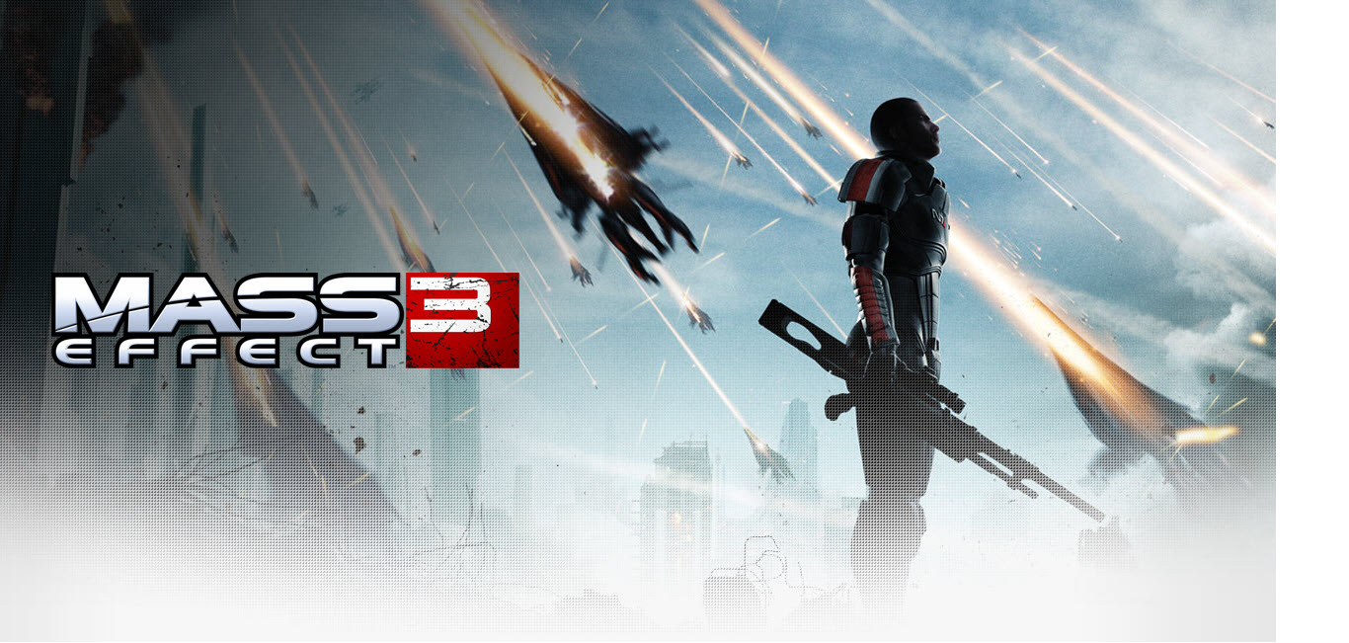
“Not everyone will survive. Mass Effect 3 plunges you into an all-out galactic war to take Earth back from a nearly unstoppable foe – and how you fight that war is entirely up to you.”
Few games come with the amount of baggage Mass Effect 3 has swirling around it. As the culmination of BioWare's epic sci-fi RPG trilogy, Mass Effect 3 hasn't garnered this groundswell in an artificial way. Rather, anticipation steadily sits at a fever pitch because the previous installments -- Mass Effect, and especially Mass Effect 2 -- rate amongst the best games ever made. And in many ways, Mass Effect 3 has set the bar even higher as the worthy conclusion to one of the finest stories ever told in gaming history, even if it's still admittedly imperfect.
Mass Effect 3 is a game that cannot be done justice through merely writing about the emotional impact and gut wrenchingly intense choices that have gamers raving. This ethical journey defined through powerful storytelling is an experience every gamer must embark upon for themselves. The poignant moments of soul-searching and emotional turmoil that overwhelm fans lead toward an opportunity to reminiscence and reflect upon the series as a whole, though not necessarily due to the most satisfying of video game conclusions.
An ancient alien race, known only as “Reapers”, has launched an all – out invasion leaving nothing but a trail of destruction in their wake. Earth has been taken, the galaxy is on the verge of total annihilation, and you are the only one who can stop them.
Mass Effect 3 is yet another sci – fi epic launched by EA succeeding the uncanny Mass Effect 2. It has been tagged as “Mass Effect 3: Take Earth Back”.
Load your arsenal because in this game the price of failure is extinction. You are Commander Shepard (N7 Elite Force), a character that you can forge in your own image. You determine how events will play out, which planets to explore, and whom to form alliances with as you rally a force to eliminate the Reaper threat once and for all. How you wage this war is completely up to you: go into combat with guns blazing or use cover to plan a more tactical assault. Utilize your squad to full effect or take a lone wolf approach. Rain death from a distance or go toe to toe with enemies using devastating melee attacks. Mass Effect 3 will react to each decision you make as you play through a truly unique experience of your own creation.

KEY FEATURES
- Play Your Way– Choose a fast-paced cinematic experience or delve into a deeper, more choice-driven narrative. Either way, intense combat propels the action as you fight to unite a war-torn galaxy against a common enemy.
- A Rich, Branching Story — Interactive storytelling delivers an experience unlike any other, with multiple outcomes determined by your choices. Mass Effect 3 will redefine what you know about emotionally engaging story.
- Unleash a Customizable Arsenal — Build your character and squad with dozens of unique weapons and abilities, each with powerful upgrades and modifications.
- Class-Based Co-operative Multiplayer Missions — Fight the war alongside your friends in four-player co-op missions. Choose from a variety of races and classes and combine your skills to overcome impossible odds. Your success can have an impact on the outcome of your single-player experience.
- Adrenaline-Pumping Gameplay — Feel every bullet impact, roll into cover, and unleash devastating heavy weapons in an intense and pulse-pounding action-shooter game.
- Ruthless and Intelligent Enemies — Battle merciless enemies that will consistently challenge your best combat tactics and put you on the edge of your seat.
